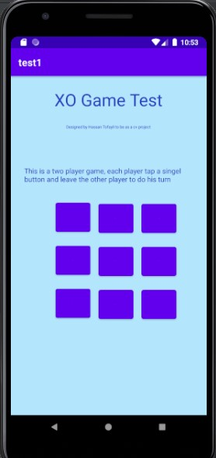

XO_Game

Android Apk

Hassan Tofayli | Android App | 2021

This Game is not uploaded to the Google Play Store.

